Introduction to Hibernate 3.0
What is Hibernate?
Hibernate 3.0, the latest Open Source persistence technology at the heart of J2EE EJB 3.0 is available for download from Hibernet.org.The Hibernate 3.0 core is 68,549 lines of Java code together with 27,948 lines of unit tests, all freely available under the LGPL, and has been in development for well over a year. Hibernate maps the Java classes to the database tables. It also provides the data query and retrieval facilities that significantly reduces the development time. Hibernate is not the best solutions for data centric applications that only uses the stored-procedures to implement the business logic in database. It is most useful with object-oriented domain modes and business logic in the Java-based middle-tier. Hibernate allows transparent persistence that enables the applications to switch any database. Hibernate can be used in Java Swing applications, Java Servlet-based applications, or J2EE applications using EJB session beans.
Features of Hibernate
- Hibernate 3.0 provides three full-featured query facilities: Hibernate Query Language, the newly enhanced Hibernate Criteria Query API, and enhanced support for queries expressed in the native SQL dialect of the database.
- Filters for working with temporal (historical), regional or permissioned data.
- Enhanced Criteria query API: with full support for projection/aggregation and subselects.
- Runtime performance monitoring: via JMX or local Java API, including a second-level cache browser.
- Eclipse support, including a suite of Eclipse plug-ins for working with Hibernate 3.0, including mapping editor, interactive query prototyping, schema reverse engineering tool.
- Hibernate is Free under LGPL: Hibernate can be used to develop/package and distribute the applications for free.
- Hibernate is Scalable: Hibernate is very performant and due to its dual-layer architecture can be used in the clustered environments.
- Less Development Time: Hibernate reduces the development timings as it supports inheritance, polymorphism, composition and the Java Collection framework.
- Automatic Key Generation: Hibernate supports the automatic generation of primary key for your.
- JDK 1.5 Enhancements: The new JDK has been released as a preview earlier this year and we expect a slow migration to the new 1.5 platform throughout 2004. While Hibernate3 still runs perfectly with JDK 1.2, Hibernate3 will make use of some new JDK features. JSR 175 annotations, for example, are a perfect fit for Hibernate metadata and we will embrace them aggressively. We will also support Java generics, which basically boils down to allowing type safe collections.
- EJB3-style persistence operations: EJB3 defines the create() and merge() operations, which are slightly different to Hibernate's saveOrUpdate() and saveOrUpdateCopy() operations. Hibernate3 will support all four operations as methods of the Session interface.
- Hibernate XML binding enables data to be represented as XML and POJOs interchangeably.
- The EJB3 draft specification support for POJO persistence and annotations

Hibernate Architecture
In this lesson you will learn the architecture of Hibernate. The following diagram describes the high level architecture of hibernate:
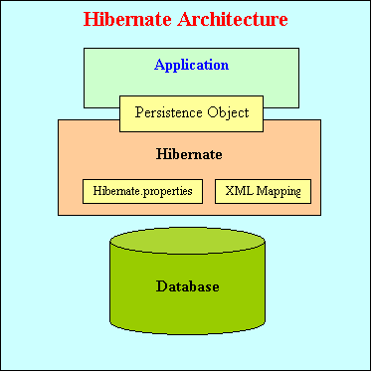
The above diagram shows that Hibernate is using the database and configuration data to provide persistence services (and persistent objects) to the application.
To use Hibernate, it is required to create Java classes that represents the table in the database and then map the instance variable in the class with the columns in the database. Then Hibernate can be used to perform operations on the database like select, insert, update and delete the records in the table. Hibernate automatically creates the query to perform these operations.
Hibernate architecture has three main components:
- Connection Management
Hibernate Connection management service provide efficient management of the database connections. Database connection is the most expensive part of interacting with the database as it requires a lot of resources of open and close the database connection.
- Transaction management:
Transaction management service provide the ability to the user to execute more than one database statements at a time.
- Object relational mapping:
Object relational mapping is technique of mapping the data representation from an object model to a relational data model. This part of the hibernate is used to select, insert, update and delete the records form the underlying table. When we pass an object to a Session.save() method, Hibernate reads the state of the variables of that object and executes the necessary query.
Hibernate is very good tool as far as object relational mapping is concern, but in terms of connection management and transaction management, it is lacking in performance and capabilities. So usually hibernate is being used with other connection management and transaction management tools. For example apache DBCP is used for connection pooling with the Hibernate.
Hibernate provides a lot of flexibility in use. It is called "Lite" architecture when we only uses the object relational mapping component. While in "Full Cream" architecture all the three component Object Relational mapping, Connection Management and Transaction Management) are used.

Writing First Hibernate Code
In this section I will show you how to create a simple program to insert record in MySQL database. You can run this program from Eclipse or from command prompt as well. I am assuming that you are familiar with MySQL and Eclipse environment.
Configuring Hibernate
In this application Hibernate provided connection pooling and transaction management is used for simplicity. Hibernate uses the hibernate.cfg.xml to create the connection pool and setup required environment. Here is the code:
<?xml version='1.0' encoding='utf-8'?>
<!DOCTYPE hibernate-configuration PUBLIC
"-//Hibernate/Hibernate Configuration DTD//EN"
"http://hibernate.sourceforge.net/hibernate-configuration-3.0.dtd">
<hibernate-configuration>
<session-factory>
<property name="hibernate.connection.driver_class">com.mysql.jdbc.Driver</property>
<property name="hibernate.connection.url">jdbc:mysql://localhost/hibernatetutorial</property>
<property name="hibernate.connection.username">root</property>
<property name="hibernate.connection.password"></property>
<property name="hibernate.connection.pool_size">10</property>
<property name="show_sql">true</property>
<property name="dialect">org.hibernate.dialect.MySQLDialect</property>
<property name="hibernate.hbm2ddl.auto">update</property>
<!-- Mapping files -->
<mapping resource="contact.hbm.xml"/>
</session-factory>
</hibernate-configuration>
In the above configuration file we specified to use the "hibernatetutorial" which is running on localhost and the user of the database is root with no password. The dialect property is org.hibernate.dialect.MySQLDialect which tells the Hibernate that we are using MySQL Database. Hibernate supports many database. With the use of the Hibernate (Object/Relational Mapping and Transparent Object Persistence for Java and SQL Databases), we can use the following databases dialect type property:
- DB2 - org.hibernate.dialect.DB2Dialect
- HypersonicSQL - org.hibernate.dialect.HSQLDialect
- Informix - org.hibernate.dialect.InformixDialect
- Ingres - org.hibernate.dialect.IngresDialect
- Interbase - org.hibernate.dialect.InterbaseDialect
- Pointbase - org.hibernate.dialect.PointbaseDialect
- PostgreSQL - org.hibernate.dialect.PostgreSQLDialect
- Mckoi SQL - org.hibernate.dialect.MckoiDialect
- Microsoft SQL Server - org.hibernate.dialect.SQLServerDialect
- MySQL - org.hibernate.dialect.MySQLDialect
- Oracle (any version) - org.hibernate.dialect.OracleDialect
- Oracle 9 - org.hibernate.dialect.Oracle9Dialect
- Progress - org.hibernate.dialect.ProgressDialect
- FrontBase - org.hibernate.dialect.FrontbaseDialect
- SAP DB - org.hibernate.dialect.SAPDBDialect
- Sybase - org.hibernate.dialect.SybaseDialect
- Sybase Anywhere - org.hibernate.dialect.SybaseAnywhereDialect
The <mapping resource="contact.hbm.xml"/> property is the mapping for our contact table.
Writing First Persistence Class
Hibernate uses the Plain Old Java Objects (POJOs) classes to map to the database table. We can configure the variables to map to the database column. Here is the code for Contact.java:
package roseindia.tutorial.hibernate;
/**
* @author Deepak Kumar
*
* Java Class to map to the datbase Contact Table
*/
public class Contact {
private String firstName;
private String lastName;
private String email;
private long id;
/**
* @return Email
*/
public String getEmail() {
return email;
}
/**
* @return First Name
*/
public String getFirstName() {
return firstName;
}
/**
* @return Last name
*/
public String getLastName() {
return lastName;
}
/**
* @param string Sets the Email
*/
public void setEmail(String string) {
email = string;
}
/**
* @param string Sets the First Name
*/
public void setFirstName(String string) {
firstName = string;
}
/**
* @param string sets the Last Name
*/
public void setLastName(String string) {
lastName = string;
}
/**
* @return ID Returns ID
*/
public long getId() {
return id;
}
/**
* @param l Sets the ID
*/
public void setId(long l) {
id = l;
}
}
Mapping the Contact Object to the Database Contact table
The file contact.hbm.xml is used to map Contact Object to the Contact table in the database. Here is the code for contact.hbm.xml:
<?xml version="1.0"?>
<!DOCTYPE hibernate-mapping PUBLIC
"-//Hibernate/Hibernate Mapping DTD 3.0//EN"
"http://hibernate.sourceforge.net/hibernate-mapping-3.0.dtd">
<hibernate-mapping>
<class name="roseindia.tutorial.hibernate.Contact" table="CONTACT">
<id name="id" type="long" column="ID" >
<generator class="assigned"/>
</id>
<property name="firstName">
<column name="FIRSTNAME" />
</property>
<property name="lastName">
<column name="LASTNAME"/>
</property>
<property name="email">
<column name="EMAIL"/>
</property>
</class>
</hibernate-mapping>
Setting Up MySQL Database
In the configuration file(hibernate.cfg.xml) we have specified to use hibernatetutorial database running on localhost. So, create the databse ("hibernatetutorial") on the MySQL server running on localhost.
Developing Code to Test Hibernate example
Now we are ready to write a program to insert the data into database. We should first understand about the Hibernate's Session. Hibernate Session is the main runtime interface between a Java application and Hibernate. First we are required to get the Hibernate Session.SessionFactory allows application to create the Hibernate Sesssion by reading the configuration from hibernate.cfg.xml file. Then the save method on session object is used to save the contact information to the database:
session.save(contact)
Here is the code of FirstExample.java
package roseindia.tutorial.hibernate;
import org.hibernate.Session;
import org.hibernate.SessionFactory;
import org.hibernate.cfg.Configuration;
/**
* @author Deepak Kumar
*
* http://www.roseindia.net
* Hibernate example to inset data into Contact table
*/
public class FirstExample {
public static void main(String[] args) {
Session session = null;
try{
// This step will read hibernate.cfg.xml and prepare hibernate for use
SessionFactory sessionFactory = new Configuration().configure().buildSessionFactory();
session =sessionFactory.openSession();
//Create new instance of Contact and set values in it by reading them from form object
System.out.println("Inserting Record");
Contact contact = new Contact();
contact.setId(3);
contact.setFirstName("Deepak");
contact.setLastName("Kumar");
contact.setEmail("deepak_38@yahoo.com");
session.save(contact);
System.out.println("Done");
}catch(Exception e){
System.out.println(e.getMessage());
}finally{
// Actual contact insertion will happen at this step
session.flush();
session.close();
}
}
}
In the next section I will show how to run and test the program.

Hibernate is free open source software it can be download from http://www.hibernate.org/6.html. Visit the site and download Hibernate 3.0. You can download the Hibernate and install it yourself. But I have provided very thing in one zip file. Download the example code and library from here and extract the content in your favorite directory say "C:\hibernateexample". Download file contains the Eclipse project. To run the example you should have the Eclipse IDE on your machine. Start the Eclipse project and select Java Project as shown below.
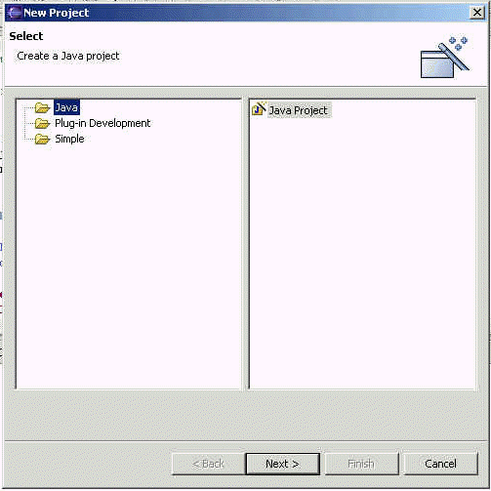
Click on "Next" button. In the new screen, enter "hibernateexample" as project name and browse the extracted directory "C:\hibernateexample".
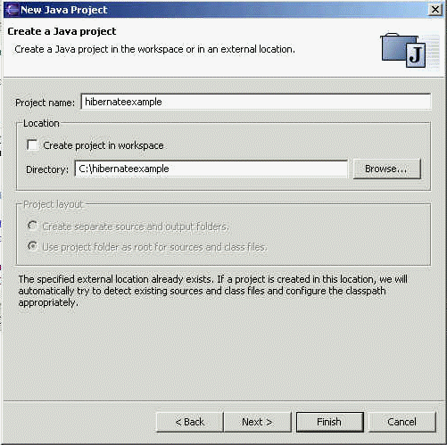
Click on "Next" button. In the next screen leave the output folder as default "hibernateexample/bin" .
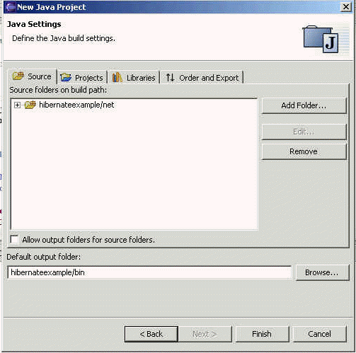
Click on the "Finish" button.
Now Open the FirstExample.java in the editor as show below.
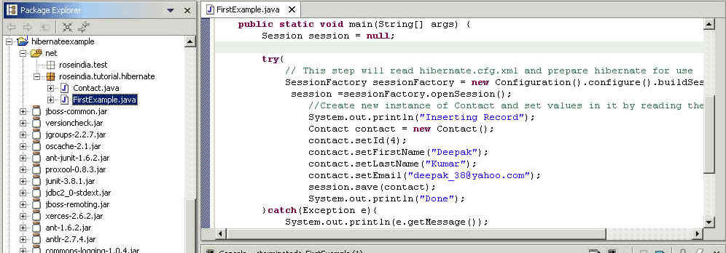

Copy contact.hbm.xml, and hibernate.cfg.xml in the bin directory of the project using windows explorer. To run the example select Run-> Run As -> Java Application from the menu bar as shown below.
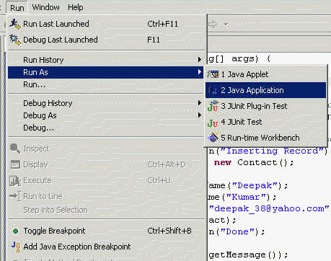
This will run the Hibernate example program in Eclipse following output will displayed on the Eclipse Console.
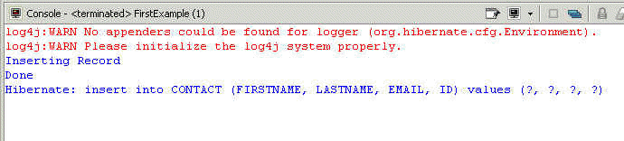
In this section I showed you how to run the our first Hibernate 3.0 example.

Understanding Hibernate O/R Mapping
In the last example we created contact.hbm.xml to map Contact Object to the Contact table in the database. Now let's understand the each component of the mapping file.
To recall here is the content of contact.hbm.xml:
<?xml version="1.0"?>
<!DOCTYPE hibernate-mapping PUBLIC
"-//Hibernate/Hibernate Mapping DTD 3.0//EN"
"http://hibernate.sourceforge.net/hibernate-mapping-3.0.dtd">
<hibernate-mapping>
<class name="roseindia.tutorial.hibernate.Contact" table="CONTACT">
<id name="id" type="long" column="ID" >
<generator class="assigned"/>
</id>
<property name="firstName">
<column name="FIRSTNAME" />
</property>
<property name="lastName">
<column name="LASTNAME"/>
</property>
<property name="email">
<column name="EMAIL"/>
</property>
</class>
</hibernate-mapping>

Hibernate mapping documents are simple xml documents. Here are important elements of the mapping file:.
- <hibernate-mapping> element
The first or root element of hibernate mapping document is <hibernate-mapping> element. Between the <hibernate-mapping> tag class element(s) are present.
- <class> element
The <Class> element maps the class object with corresponding entity in the database. It also tells what table in the database has to access and what column in that table it should use. Within one <hibernate-mapping> element, several <class> mappings are possible.
- <id> element
The <id> element in unique identifier to identify and object. In fact <id> element map with the primary key of the table. In our code :
<id name="id" type="long" column="ID" >
primary key maps to the ID field of the table CONTACT. The attributes of the id element are:
  - name: The property name used by the persistent class.
  - column: The column used to store the primary key value.
  - type: The Java data type used.
  - unsaved-value: This is the value used to determine if a class has been made persistent. If the value of the id attribute is null, then it means that this object has not been persisted.
- <generator> element
The <generator> method is used to generate the primary key for the new record. Here is some of the commonly used generators :
* Increment - This is used to generate primary keys of type long, short or int that are unique only. It should not be used in the clustered deployment environment.
* Sequence - Hibernate can also use the sequences to generate the primary key. It can be used with DB2, PostgreSQL, Oracle, SAP DB databases.
* Assigned - Assigned method is used when application code generates the primary key.
- <property> element
The property elements define standard Java attributes and their mapping into database schema. The property element supports the column child element to specify additional properties, such as the index name on a column or a specific column type.

Understanding Hibernate <generator> element
In this lesson you will learn about hibernate <generator> method in detail. Hibernate generator element generates the primary key for new record. There are many options provided by the generator method to be used in different situations.
The <generator> element
This is the optional element under <id> element. The <generator> element is used to specify the class name to be used to generate the primary key for new record while saving a new record. The <param> element is used to pass the parameter (s) to the class. Here is the example of generator element from our first application:
<generator class="assigned"/>
In this case <generator> element do not generate the primary key and it is required to set the primary key value before calling save() method.
Here are the list of some commonly used generators in hibernate:
Generator | Description
increment | It generates identifiers of type long, short or int that are unique only when no other process is inserting data into the same table. It should not the used in the clustered environment.
identity | It supports identity columns in DB2, MySQL, MS SQL Server, Sybase and HypersonicSQL. The returned identifier is of type long, short or int.
sequence | The sequence generator uses a sequence in DB2, PostgreSQL, Oracle, SAP DB, McKoi or a generator in Interbase. The returned identifier is of type long, short or int
hilo | The hilo generator uses a hi/lo algorithm to efficiently generate identifiers of type long, short or int, given a table and column (by default hibernate_unique_key and next_hi respectively) as a source of hi values. The hi/lo algorithm generates identifiers that are unique only for a particular database. Do not use this generator with connections enlisted with JTA or with a user-supplied connection.
seqhilo | The seqhilo generator uses a hi/lo algorithm to efficiently generate identifiers of type long, short or int, given a named database sequence.
uuid | The uuid generator uses a 128-bit UUID algorithm to generate identifiers of type string, unique within a network (the IP address is used). The UUID is encoded as a string of hexadecimal digits of length 32.
guid | It uses a database-generated GUID string on MS SQL Server and MySQL.
native | It picks identity, sequence or hilo depending upon the capabilities of the underlying database.
assigned | lets the application to assign an identifier to the object before save() is called. This is the default strategy if no <generator> element is specified.
select | retrieves a primary key assigned by a database trigger by selecting the row by some unique key and retrieving the primary key value.
foreign | uses the identifier of another associated object. Usually used in conjunction with a <one-to-one> primary key association.

Using Hibernate <generator> to generate id incrementally
As we have seen in the last section that the increment class generates identifiers of type long, short or int that are unique only when no other process is inserting data into the same table. In this lesson I will show you how to write running program to demonstrate it. You should not use this method to generate the primary key in case of clustured environment.
In this we will create a new table in database, add mappings in the contact.hbm.xml file, develop the POJO class (Book.java), write the program to test it out.
Create Table in the mysql database:
User the following sql statement to create a new table in the database.
CREATE TABLE `book` (
`id` int(11) NOT NULL default '0',
`bookname` varchar(50) default NULL,
PRIMARY KEY (`id`)
) TYPE=MyISAM
Developing POJO Class (Book.java)
Book.java is our POJO class which is to be persisted to the database table "book".
/**
* @author Deepak Kumar
*
* http://www.roseindia.net
* Java Class to map to the database Book table
*/
package roseindia.tutorial.hibernate;
public class Book {
private long lngBookId;
private String strBookName;
/**
* @return Returns the lngBookId.
*/
public long getLngBookId() {
return lngBookId;
}
/**
* @param lngBookId The lngBookId to set.
*/
public void setLngBookId(long lngBookId) {
this.lngBookId = lngBookId;
}
/**
* @return Returns the strBookName.
*/
public String getStrBookName() {
return strBookName;
}
/**
* @param strBookName The strBookName to set.
*/
public void setStrBookName(String strBookName) {
this.strBookName = strBookName;
}
}
Adding Mapping entries to contact.hbm.xml
Add the following mapping code into the contact.hbm.xml file
<class name="roseindia.tutorial.hibernate.Book" table="book">
<id name="lngBookId" type="long" column="id" >
<generator class="increment"/>
</id>
<property name="strBookName">
<column name="bookname" />
</property>
</class>
Note that we have used increment for the generator class. *After adding the entries to the xml file copy it to the bin directory of your hibernate eclipse project(this step is required if you are using eclipse).
Write the client program and test it out
Here is the code of our client program to test the application.
/**
* @author Deepak Kumar
*
* http://www.roseindia.net
* Example to show the increment class of hibernate generator element to
* automatically generate the primay key
*/
package roseindia.tutorial.hibernate;
//Hibernate Imports
import org.hibernate.Session;
import org.hibernate.SessionFactory;
import org.hibernate.cfg.Configuration;
public class IdIncrementExample {
public static void main(String[] args) {
Session session = null;
try{
// This step will read hibernate.cfg.xml and prepare hibernate for use
SessionFactory sessionFactory = new Configuration().configure().buildSessionFactory();
session =sessionFactory.openSession();
org.hibernate.Transaction tx = session.beginTransaction();
//Create new instance of Contact and set values in it by reading them from form object
System.out.println("Inserting Book object into database..");
Book book = new Book();
book.setStrBookName("Hibernate Tutorial");
session.save(book);
System.out.println("Book object persisted to the database.");
tx.commit();
session.flush();
session.close();
}catch(Exception e){
System.out.println(e.getMessage());
}finally{
}
}
}
To test the program Select Run->Run As -> Java Application from the eclipse menu bar. This will create a new record into the book table.

Hibernate Query Language
Hibernate Query Language or HQL for short is extremely powerful query language. HQL is much like SQL and are case-insensitive, except for the names of the Java Classes and properties. Hibernate Query Language is used to execute queries against database. Hibernate automatically generates the sql query and execute it against underlying database if HQL is used in the application. HQL is based on the relational object models and makes the SQL object oriented. Hibernate Query Language uses Classes and properties instead of tables and columns. Hibernate Query Language is extremely powerful and it supports Polymorphism, Associations, Much less verbose than SQL.
There are other options that can be used while using Hibernate. These are Query By Criteria (QBC) and Query BY Example (QBE) using Criteria API and the Native SQL queries. In this lesson we will understand HQL in detail.
Why to use HQL?
- Full support for relational operations: HQL allows representing SQL queries in the form of objects. Hibernate Query Language uses Classes and properties instead of tables and columns.
- Return result as Object: The HQL queries return the query result(s) in the form of object(s), which is easy to use. This elemenates the need of creating the object and populate the data from result set.
- Polymorphic Queries: HQL fully supports polymorphic queries. Polymorphic queries results the query results along with all the child objects if any.
- Easy to Learn: Hibernate Queries are easy to learn and it can be easily implemented in the applications.
- Support for Advance features: HQL contains many advance features such as pagination, fetch join with dynamic profiling, Inner/outer/full joins, Cartesian products. It also supports Projection, Aggregation (max, avg) and grouping, Ordering, Sub queries and SQL function calls.
- Database independent: Queries written in HQL are database independent (If database supports the underlying feature).

Understanding HQL Syntax
Any Hibernate Query Language may consist of following elements:
- Clauses
- Aggregate functions
- Subqueries
Clauses in the HQL are:
- from
- select
- where
- order by
- group by
Aggregate functions are:
- avg(...), sum(...), min(...), max(...)
- count(*)
- count(...), count(distinct ...), count(all...)
Subqueries
Subqueries are nothing but its a query within another query. Hibernate supports Subqueries if the underlying database supports it.
Preparing table for HQL Examples
In this lesson we will create insurance table and populate it with the data. We will use insurance table for rest of the HQL tutorial.
To create the insurance table and insert the sample data, run the following sql query:
/*Table structure for table `insurance` */

drop table if exists `insurance`;

CREATE TABLE `insurance` (
`ID` int(11) NOT NULL default '0',
`insurance_name` varchar(50) default NULL,
`invested_amount` int(11) default NULL,
`investement_date` datetime default NULL,
PRIMARY KEY (`ID`)
) TYPE=MyISAM;

/*Data for the table `insurance` */

insert into `insurance` values (1,'Car Insurance',1000,'2005-01-05 00:00:00');
insert into `insurance` values (2,'Life Insurance',100,'2005-10-01 00:00:00');
insert into `insurance` values (3,'Life Insurance',500,'2005-10-15 00:00:00');
insert into `insurance` values (4,'Car Insurance',2500,'2005-01-01 00:00:00');
insert into `insurance` values (5,'Dental Insurance',500,'2004-01-01 00:00:00');
insert into `insurance` values (6,'Life Insurance',900,'2003-01-01 00:00:00');
insert into `insurance` values (7,'Travel Insurance',2000,'2005-02-02 00:00:00');
insert into `insurance` values (8,'Travel Insurance',600,'2005-03-03 00:00:00');
insert into `insurance` values (9,'Medical Insurance',700,'2005-04-04 00:00:00');
insert into `insurance` values (10,'Medical Insurance',900,'2005-03-03 00:00:00');
insert into `insurance` values (11,'Home Insurance',800,'2005-02-02 00:00:00');
insert into `insurance` values (12,'Home Insurance',750,'2004-09-09 00:00:00');
insert into `insurance` values (13,'Motorcycle Insurance',900,'2004-06-06 00:00:00');
insert into `insurance` values (14,'Motorcycle Insurance',780,'2005-03-03 00:00:00');
Above Sql query will create insurance table and add the following data:
ID | insurance_name | invested_amount | investement_date
1 | Car Insurance | 1000 | 2005-01-05 00:00:00
2 | Life Insurance | 100 | 2005-10-01 00:00:00
3 | Life Insurance | 500 | 2005-10-15 00:00:00
4 | Car Insurance | 2500 | 2005-01-01 00:00:00
5 | Dental Insurance | 500 | 2004-01-01 00:00:00
6 | Life Insurance | 900 | 2003-01-01 00:00:00
7 | Travel Insurance | 2000 | 2005-02-02 00:00:00
8 | Travel Insurance | 600 | 2005-03-03 00:00:00
9 | Medical Insurance | 700 | 2005-04-04 00:00:00
10 | Medical Insurance | 900 | 2005-03-03 00:00:00
11 | Home Insurance | 800 | 2005-02-02 00:00:00
12 | Home Insurance | 750 | 2004-09-09 00:00:00
13 | Motorcycle Insurance | 900 | 2004-06-06 00:00:00
14 | Motorcycle Insurance | 780 | 2005-03-03 00:00:00
In the future lessons we will use this table to write different HQL examples.

Writing ORM for Insurance table
In this lesson we will write the java class and add necessary code in the contact.hbm.xml file.
Create POJO class:
Here is the code of our java file (Insurance.java), which we will map to the insurance table.
package roseindia.tutorial.hibernate;
import java.util.Date;
/**
* @author Deepak Kumar
*
* http://www.roseindia.net
* Java Class to map to the database insurance table
*/
public class Insurance {
private long lngInsuranceId;
private String insuranceName;
private int investementAmount;
private Date investementDate;
/**
* @return Returns the insuranceName.
*/
public String getInsuranceName() {
return insuranceName;
}
/**
* @param insuranceName The insuranceName to set.
*/
public void setInsuranceName(String insuranceName) {
this.insuranceName = insuranceName;
}
/**
* @return Returns the investementAmount.
*/
public int getInvestementAmount() {
return investementAmount;
}
/**
* @param investementAmount The investementAmount to set.
*/
public void setInvestementAmount(int investementAmount) {
this.investementAmount = investementAmount;
}
/**
* @return Returns the investementDate.
*/
public Date getInvestementDate() {
return investementDate;
}
/**
* @param investementDate The investementDate to set.
*/
public void setInvestementDate(Date investementDate) {
this.investementDate = investementDate;
}
/**
* @return Returns the lngInsuranceId.
*/
public long getLngInsuranceId() {
return lngInsuranceId;
}
/**
* @param lngInsuranceId The lngInsuranceId to set.
*/
public void setLngInsuranceId(long lngInsuranceId) {
this.lngInsuranceId = lngInsuranceId;
}
}
Adding mappings into contact.hbm.xml file
Add the following code into contact.hbm.xml file.
<class name="roseindia.tutorial.hibernate.Insurance" table="insurance">
<id name="lngInsuranceId" type="long" column="ID" >
<generator class="increment"/>
</id>

<property name="insuranceName">
<column name="insurance_name" />
</property>
<property name="investementAmount">
<column name="invested_amount" />
</property>
<property name="investementDate">
<column name="investement_date" />
</property>
</class>

Now we have created the POJO class and necessary mapping into contact.hbm.xml file

HQL from clause Example
In this example you will learn how to use the HQL from clause. The from clause is the simplest possible Hibernate Query. Example of from clause is:
from Insurance insurance
Here is the full code of the from clause example:
package roseindia.tutorial.hibernate;
import org.hibernate.Session;
import org.hibernate.*;
import org.hibernate.cfg.*;
import java.util.*;
/**
* @author Deepak Kumar
*
* http://www.roseindia.net
* Select HQL Example
*/
public class SelectHQLExample {
public static void main(String[] args) {
Session session = null;
try{
// This step will read hibernate.cfg.xml and prepare hibernate for use
SessionFactory sessionFactory = new Configuration().configure().buildSessionFactory();
session =sessionFactory.openSession();
//Using from Clause
String SQL_QUERY ="from Insurance insurance";
Query query = session.createQuery(SQL_QUERY);
for(Iterator it=query.iterate();it.hasNext();){
Insurance insurance=(Insurance)it.next();
System.out.println("ID: " + insurance.getLngInsuranceId());
System.out.println("First Name: " + insurance.getInsuranceName());
}
session.close();
}catch(Exception e){
System.out.println(e.getMessage());
}finally{
}
}
}

To run the example select Run-> Run As -> Java Application from the menu bar. Following out is displayed in the Eclipse console:
log4j:WARN No appenders could be found for logger (org.hibernate.cfg.Environment).
log4j:WARN Please initialize the log4j system properly.
Hibernate: select insurance0_.ID as col_0_0_ from insurance insurance0_
ID: 1
Hibernate: select insurance0_.ID as ID0_, insurance0_.insurance_name as insurance2_2_0_, insurance0_.invested_amount as invested3_2_0_, insurance0_.investement_date as investem4_2_0_ from insurance insurance0_ where insurance0_.ID=?
First Name: Car Insurance
ID: 2
Hibernate: select insurance0_.ID as ID0_, insurance0_.insurance_name as insurance2_2_0_, insurance0_.invested_amount as invested3_2_0_, insurance0_.investement_date as investem4_2_0_ from insurance insurance0_ where insurance0_.ID=?

Hibernate Select Clause
In this lesson we will write example code to select the data from Insurance table using Hibernate Select Clause. The select clause picks up objects and properties to return in the query result set. Here is the query:
Select insurance.lngInsuranceId,insurance.insuranceName,insurance.investementAmount,insurance.investementDate from Insurance insurance
which selects all the rows (insurance.lngInsuranceId, insurance.insuranceName, insurance.investementAmount, insurance.investementDate) from Insurance table.
Hibernate generates the necessary sql query and selects all the records from Insurance table. Here is the code of our java file which shows how select HQL can be used:
package roseindia.tutorial.hibernate;
import org.hibernate.Session;
import org.hibernate.*;
import org.hibernate.cfg.*;
import java.util.*;
/**
* @author Deepak Kumar
*
* http://www.roseindia.net
* HQL Select Clause Example
*/
public class SelectClauseExample {
public static void main(String[] args) {
Session session = null;
try{
// This step will read hibernate.cfg.xml and prepare hibernate for use
SessionFactory sessionFactory = new Configuration().configure()
.buildSessionFactory();
session =sessionFactory.openSession();
//Create Select Clause HQL
String SQL_QUERY ="Select insurance.lngInsuranceId,insurance.insuranceName," +
"insurance.investementAmount,insurance.investementDate from Insurance insurance";
Query query = session.createQuery(SQL_QUERY);
for(Iterator it=query.iterate();it.hasNext();){
Object[] row = (Object[]) it.next();
System.out.println("ID: " + row[0]);
System.out.println("Name: " + row[1]);
System.out.println("Amount: " + row[2]);
}
session.close();
}catch(Exception e){
System.out.println(e.getMessage());
}finally{
}
}
}
To run the example select Run-> Run As -> Java Application from the menu bar. Following out is displayed in the Eclipse console:
Hibernate: select insurance0_.ID as col_0_0_, insurance0_.insurance_name as col_1_0_, insurance0_.invested_amount as col_2_0_, insurance0_.investement_date as col_3_0_ from insurance insurance0_
ID: 1
Name: Car Insurance
Amount: 1000
ID: 2
Name: Life Insurance
Amount: 100
ID: 3
Name: Life Insurance
Amount: 500
ID: 4
Name: Car Insurance
Amount: 2500

Hibernate Criteria Query Example
The Criteria interface allows to create and execute object-oriented queries. It is powerful alternative to the HQL but has own limitations. Criteria Query is used mostly in case of multi criteria search screens, where HQL is not very effective.
The interface org.hibernate.Criteria is used to create the criterion for the search. The org.hibernate.Criteria interface represents a query against a persistent class. The Session is a factory for Criteria instances. Here is a simple example of Hibernate Criterial Query:
package roseindia.tutorial.hibernate;
import org.hibernate.Session;
import org.hibernate.*;
import org.hibernate.cfg.*;
import java.util.*;
/**
* @author Deepak Kumar
*
* http://www.roseindia.net Hibernate Criteria Query Example
*
*/public class HibernateCriteriaQueryExample {
public static void main(String[] args) {
Session session = null;
try {
// This step will read hibernate.cfg.xml and prepare hibernate for
// use
SessionFactory sessionFactory = new Configuration().configure()
.buildSessionFactory();
session = sessionFactory.openSession();
//Criteria Query Example
Criteria crit = session.createCriteria(Insurance.class);
List insurances = crit.list();
for(Iterator it = insurances.iterator();it.hasNext();){
Insurance insurance = (Insurance) it.next();
System.out.println("ID: " + insurance.getLngInsuranceId());
System.out.println("Name: " + insurance.getInsuranceName());
}
session.close();
} catch (Exception e) {
System.out.println(e.getMessage());
} finally {
}
}
}
The above Criteria Query example selects all the records from the table and displays on the console. In the above code the following code creates a new Criteria instance, for the class Insurance:
Criteria crit = session.createCriteria(Insurance.class);
The code:
List insurances = crit.list();
creates the sql query and execute against database to retrieve the data.

Criteria Query Examples
In the last lesson we learnt how to use Criteria Query to select all the records from Insurance table. In this lesson we will learn how to restrict the results returned from the database. Different method provided by Criteria interface can be used with the help of Restrictions to restrict the records fetched from database.
Criteria Interface provides the following methods:
Method | Description
add | The Add method adds a Criterion to constrain the results to be retrieved.
addOrder | Add an Order to the result set.
createAlias | Join an association, assigning an alias to the joined entity
createCriteria | This method is used to create a new Criteria, "rooted" at the associated entity.
setFetchSize | This method is used to set a fetch size for the underlying JDBC query.
setFirstResult | This method is used to set the first result to be retrieved.
setMaxResults | This method is used to set a limit upon the number of objects to be retrieved.
uniqueResult | This method is used to instruct the Hibernate to fetch and return the unique records from database.
Class Restriction provides built-in criterion via static factory methods. Important methods of the Restriction class are:
Method | Description
Restriction.allEq | This is used to apply an "equals" constraint to each property in the key set of a Map
Restriction.between | This is used to apply a "between" constraint to the named property
Restriction.eq | This is used to apply an "equal" constraint to the named property
Restriction.ge | This is used to apply a "greater than or equal" constraint to the named property
Restriction.gt | This is used to apply a "greater than" constraint to the named property
Restriction.idEq | This is used to apply an "equal" constraint to the identifier property
Restriction.ilike | This is case-insensitive "like", similar to Postgres ilike operator
Restriction.in | This is used to apply an "in" constraint to the named property
Restriction.isNotNull | This is used to apply an "is not null" constraint to the named property
Restriction.isNull | This is used to apply an "is null" constraint to the named property
Restriction.le | This is used to apply a "less than or equal" constraint to the named property
Restriction.like | This is used to apply a "like" constraint to the named property
Restriction.lt | This is used to apply a "less than" constraint to the named property
Restriction.ltProperty | This is used to apply a "less than" constraint to two properties
Restriction.ne | This is used to apply a "not equal" constraint to the named property
Restriction.neProperty | This is used to apply a "not equal" constraint to two properties
Restriction.not | This returns the negation of an expression
Restriction.or | This returns the disjuction of two expressions
Here is an example code that shows how to use Restrictions.like method and restrict the maximum rows returned by query by setting the Criteria.setMaxResults() value to 5.
package roseindia.tutorial.hibernate;
import org.hibernate.Session;
import org.hibernate.*;
import org.hibernate.criterion.*;
import org.hibernate.cfg.*;
import java.util.*;
/**
* @author Deepak Kumar
*
* http://www.roseindia.net Hibernate Criteria Query Example
*
*/public class HibernateCriteriaQueryExample2 {
public static void main(String[] args) {
Session session = null;
try {
// This step will read hibernate.cfg.xml and prepare hibernate for
// use
SessionFactory sessionFactory = new Configuration().configure()
.buildSessionFactory();
session = sessionFactory.openSession();
//Criteria Query Example
Criteria crit = session.createCriteria(Insurance.class);
crit.add(Restrictions.like("insuranceName", "%a%")); //Like condition
crit.setMaxResults(5); //Restricts the max rows to 5
List insurances = crit.list();
for(Iterator it = insurances.iterator();it.hasNext();){
Insurance insurance = (Insurance) it.next();
System.out.println("ID: " + insurance.getLngInsuranceId());
System.out.println("Name: " + insurance.getInsuranceName());
}
session.close();
} catch (Exception e) {
System.out.println(e.getMessage());
} finally {
}
}
}

